**Student Result Management System**

|  |  |
| --- | --- |
| ***A Report Submitted*** | |
| ***In Partial Fulfillment*** | |
| ***for award of Bachelor of Technology***  ***for***  **Web Technologies (BCSE0555)** | |
|  | |
| **In** | |
| **COMPUTER SCIENCE AND ENGINEERING** | |
|  | |
| **By** | |
|  | |
| **Himanshu Pandey (Roll No. 2301330100096)**  **Drishay Chauhan (Roll No. 2301330100084)**  **Durga Maddheshiya (Roll No. 2301330100085)** | |
|  | |
| **Under the Supervision of**  **Dr. Surya Prakash Sharma**  **Assistant Professor, CSE** | |
| Home | |

# NOIDA INSTITUTE OF ENGINEERING AND TECHNOLOGY GREATER NOIDA, Affiliated to Dr. A.P.J. Abdul Kalam Technical University, Lucknow

|  |
| --- |
|  |

**DECLARATION**

We hereby declare that the work presented in this report was carried out by us. We have not submitted the matter embodied in this report for the award of any other degree or diploma of any other University or Institute.

|  |  |
| --- | --- |
| Name : Himanshu Pandey  Roll Number : 23013301000101  *(Candidate Signature)*  Name : Drishay Chauhan  Roll Number : 2301330100084  *(Candidate Signature)*  Name : Durga Maddheshiya  Roll Number : 2301330100085  *(Candidate Signature)* |  |

**CERTIFICATE**

Certified that **Himanshu Pandey** (Roll No: 23013301000101), **Drishay Chauhan** (Roll No: 23013301000084) and **Durga Maddheshiya** (Roll No: 2301330100085), has carried out the Web Technologies (BCSE0555) minor project work presented in this Project Report at **Noida Institute Of Engineering and Technology, Greater Noida** in partial fulfilment of the requirements for the award of **Bachelor of Technology**, **Computer Science and Engineering** from Dr. APJ Abdul Kalam Technical University, Lucknow under our supervision.

|  |  |
| --- | --- |
| Signature  Dr. Surya Prakash Sharma  Assistant Professor,  CSE  NIET, Greater Noida  Date: | Signature  Dr. Kumud Saxena  Professor & HOD,  CSE  NIET, Greater Noida |

**ACKNOWLEDGEMENT**

We would like to express our sincere gratitude to **Dr. Surya Prakash Sharma** for his invaluable guidance, encouragement, and constant supervision during the development of our **Web Technology Project – Student Result Management System**. His expertise, constructive feedback, and support throughout this project have been instrumental in helping us achieve our objectives successfully.

We also extend our heartfelt thanks to our respected **Head of Department (HOD)** for their continuous motivation and encouragement, which inspired us to put in our best efforts.

Finally, we are grateful to our faculty members, peers, and everyone who directly or indirectly contributed to the successful completion of this project.

# ABSTRACT

The Student Result Management System (SRMS) is a comprehensive web-based application designed to streamline and automate the process of maintaining and managing academic records of students. In traditional institutions, result management is often carried out manually, making it prone to errors, delays, and inefficiencies, especially when dealing with a large number of students and courses. This project aims to overcome these challenges by offering a secure, scalable, and user-friendly digital platform for effective result management.

The system has been implemented using PHP for server-side scripting, XML, MySQL as the relational database for structured data storage, and Bootstrap to provide a responsive and visually appealing frontend design. To ensure secure usage, a robust user authentication module has been integrated, allowing only authorized users to access and modify data. Each registered user is provided with a personalized dashboard to manage their records, ensuring privacy and security of information.

Key features of the application include the ability to add, update, delete, and search student records with ease. To improve interoperability and data portability, the system supports XML synchronization, allowing academic data to be shared or exported to other platforms in a standardized format. The modular design of the application also ensures that the system is highly adaptable and can be extended to incorporate advanced features in the future.

The SRMS has undergone rigorous testing for accuracy, reliability, usability, and performance. The results indicate that the system successfully achieves its intended objectives by minimizing errors, reducing administrative workload, and providing instant access to student results. Beyond its immediate application, the project lays the groundwork for future enhancements such as result analytics, automated grading systems, statistical performance evaluation, and integration of export features in PDF/Excel formats.

In conclusion, this project demonstrates a practical and efficient approach to modern academic record management. It not only addresses the drawbacks of manual result processing but also contributes towards the digital transformation of educational institutions, thereby enhancing transparency, accessibility, and efficiency in academic administration.

**TABLE OF CONTENTS**

**Page No.**

Declaration i

Certificate from the institute ii

Certificate from the industry iii

Acknowledgement iv Abstract v

**CHAPTER 1: INTRODUCTION** **1-2**

1.1 INTRODUCTION

1.1.1 Motivation

1.1.2 System Overview

1.1.2.1 Authentication

1.1.2.2 Student Management (CRUD)

1.1.2.3 XML Synchronization

1.2 OBJECTIVE AND SCOPE

**CHAPTER 2: LITERATURE REVIEW 3**

2.1 Review of Existing Systems

2.2 Research Gap and Motivation

**CHAPTER 3: REQUIREMENT 4**

3.1 Functional Requirements

3.2 Non-Functional Requirements

3.3 System Requirements

**CHAPTER 4: IMPLEMENTATION & TESTING 5-6**

4.1 Implementation

4.2 Testing

**CHAPTER 5: CONCLUSION AND FUTURE WORK 7**

**REFERENCES 8**

**APPENDICES 9-32**

**CHAPTER 1**

**1.1 INTRODUCTION**

Education is one of the most significant sectors in society, and with the growth of technology, digital systems have become essential for managing academic records effectively. Traditional methods of recording student results using registers or spreadsheets often lead to inefficiencies, errors, and difficulties in accessing data.

The Student Result Management System (SRMS) is a web-based application developed using PHP, MySQL, and Bootstrap. It is designed to automate the management of student records, including student details, courses, and marks. The system also provides authentication features, ensuring that each user manages their own data securely. Additionally, it incorporates XML synchronization, enabling easy export and integration with other platforms.

**1.1.1 Motivation**

* Manual result management is time-consuming and error-prone.
* Increasing student strength in educational institutions requires scalable solutions.
* Teachers and administrators need quick access to student performance data.
* A secure, web-based system ensures data integrity, multi-user support, and accessibility.

**1.1.2 System Overview**

The Student Result Management System is built around three primary modules: Authentication, Student Management (CRUD), and XML Synchronization.

**1.1.2.1 Authentication**

* Signup and Login system with password hashing using bcrypt.
* Each user has a private dashboard.
* Prevents unauthorized access via session-based login management.

**1.1.2.2 Student Management (CRUD)**

* Add, Edit, Delete, and Search student records.
* Each student entry contains Roll Number, Name, Course, and Marks.
* Search functionality allows filtering students by roll number, name, or course.

**1.1.2.3 XML Synchronization**

* All database changes are mirrored in an XML file (student_data.xml).
* Ensures interoperability with other platforms and supports data portability.

**1.2 OBJECTIVE AND SCOPE**

**Objectives:**

1. To provide an efficient digital platform for managing student results.
2. To eliminate redundancy and manual errors in traditional result systems.
3. To ensure multi-user support with secure authentication.
4. To enable portability of data through XML export.
5. To make the system scalable and user-friendly.

**Scope:**

* Suitable for schools, colleges, and training institutes.
* Can be extended to include grading systems, analytics, and PDF exports.
* Provides a foundation for future integration with Learning Management Systems (LMS).

**CHAPTER 2**

**LITERATURE REVIEW:**

2.1 Related Work

Several systems exist for managing student information, ranging from manual registers to modern ERP solutions. Traditional systems rely heavily on paperwork and spreadsheets, which lack scalability and security. ERP-based solutions are powerful but often expensive and complex for smaller institutions.

2.2 Gap Analysis

* Existing systems are often centralized, limiting portability.
* Lack of user-specific dashboards in simple implementations.
* Many systems lack real-time synchronization with XML/other formats.
* Our SRMS addresses these gaps by being lightweight, secure, extensible, and portable.

**CHAPTER 3**

**REQUIREMENT:**

**3.1 Functional Requirements**

1. User Authentication (signup/login/logout).
2. Secure password storage with hashing.
3. CRUD operations for student records.
4. Search functionality for roll number, name, or course.
5. XML file generation for all records.

**3.2 Non-Functional Requirements**

* **Usability:** Simple Bootstrap interface.
* **Scalability:** Supports multiple users without conflicts.
* **Security:** Session management, password hashing.
* **Portability:** Data export via XML.
* **Reliability:** Database transactions with error handling.

**3.3 System Requirements**

* **Software:** XAMPP (PHP 8+, MySQL), Browser (Chrome/Edge/Firefox).
* **Hardware:** 2 GB RAM, 500 MB storage (minimum).
* **OS:** Windows/Linux/MacOS.

**CHAPTER 4**

4.1 Implementation

The system is implemented using:

* Frontend: HTML, CSS, Bootstrap 5.
* Backend: PHP with XML(prepared statements).
* Database: XML with two main tables: users and students.
* XML Sync: DOMDocument in PHP to generate student_data.xml.

Modules:

1. Signup/Login: Secure authentication.
2. Dashboard: User-specific student list.
3. Add/Edit/Delete: CRUD with database + XML sync.
4. Search: Keyword-based filtering.

4.2 Testing

Test Cases:

1. Signup/Login
   * Valid user credentials → Success.
   * Invalid credentials → Error message.
2. Add Student
   * Valid input → Stored in DB + XML.
   * Missing field → Error alert.
3. Edit Student
   * Changes update DB + XML.
4. Delete Student
   * Record deleted in DB + XML updated.
5. Search Function
   * Correct results returned for keywords.

Result:  
System passed all functional and non-functional test cases successfully.

**CHAPTER 5**

Conclusion

The Student Result Management System provides a lightweight, secure, and extensible solution for managing academic records. It eliminates inefficiencies of manual systems, provides role-based dashboards, and ensures data portability with XML export. The system is suitable for small to medium institutions seeking a reliable digital solution.

Future Work

* Integration of grading system (A, B, C, etc.).
* Analytics and visualization (charts for marks distribution).
* Export results as PDF/Excel reports.
* Mobile-friendly responsive design.
* Integration with online learning platforms.

**REFERENCES**

[1] L. Welling and L. Thomson, *PHP and MySQL Web Development*. Pearson, 2016.

[2] Bootstrap Documentation, “Introduction to Bootstrap Framework,” Available Online: <https://getbootstrap.com>

[3] PHP Documentation, “PHP Manual,” Available Online: <https://www.php.net/docs.php>

[4] MySQL Documentation, “MySQL Reference Manual,” Available Online: <https://dev.mysql.com/doc>

[5] R. Nixon, *Learning PHP, MySQL & JavaScript with jQuery, CSS & HTML5*. O’Reilly Media, 5th Edition, 2018.

[6] W3Schools, “PHP MySQL Database Tutorial,” Available Online: https://www.w3schools.com/php/php_mysql_intro.asp

**APPENDICES**

(• **Appendix A:** Database Schema (users, students).

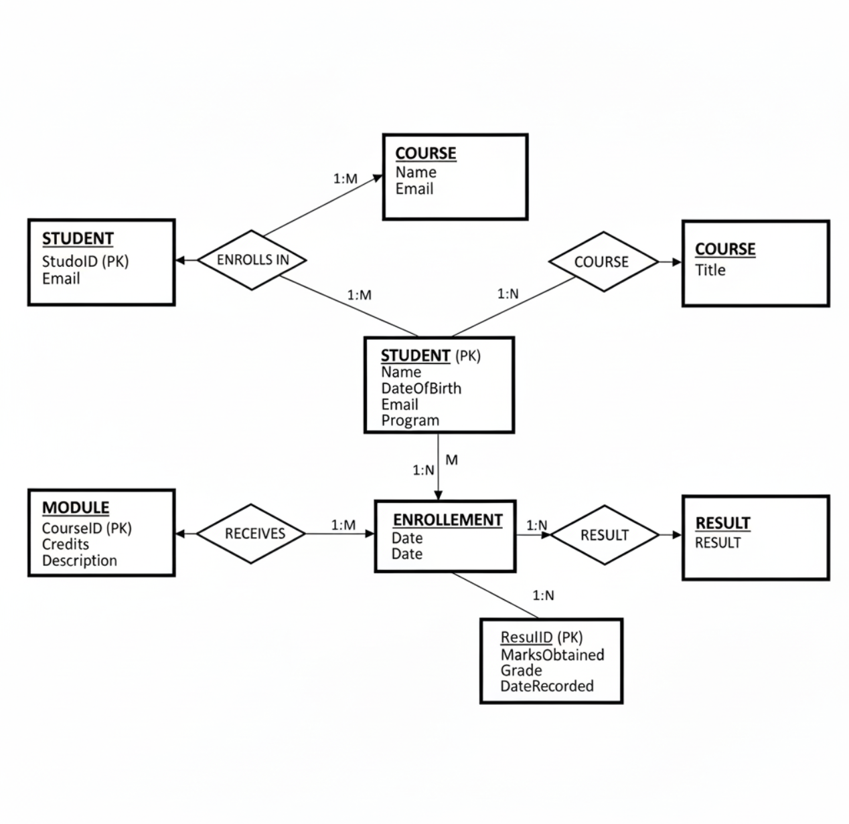ER Diagram

• **Appendix B:** Sample student_data.xml file.

**Users.xml**

<?xml version="1.0" encoding="UTF-8"?>

<users>

  <user>

    <id>1</id>

    <username>admin</username>

    <password>$2y$12$LE6WzwaGSKoR7.1CcH/uyO89K9xO57tS4kh2pRqUJKr5zFCZ7d1ey</password>

    <role>admin</role>

  </user>

<user><id>2</id><username>96</username><password>$2y$12$e4TJk3wOk1YyE9ao8/KTee0fCn88BYYTA5Jx7qJQYGTyuKMfCCdUu</password><role>student</role></user></users>

**Student_data.xml**

<?xml version="1.0" encoding="UTF-8"?>

<students>

<student><id>2</id><name>Drishay</name><roll_no>84</roll_no><ml>99</ml><sed>99</sed><dt2>99</dt2><wt>99</wt><elective1>99</elective1><elective2>99</elective2></student></students>

• **Appendix C:** Screenshots of login, dashboard, CRUD operations.

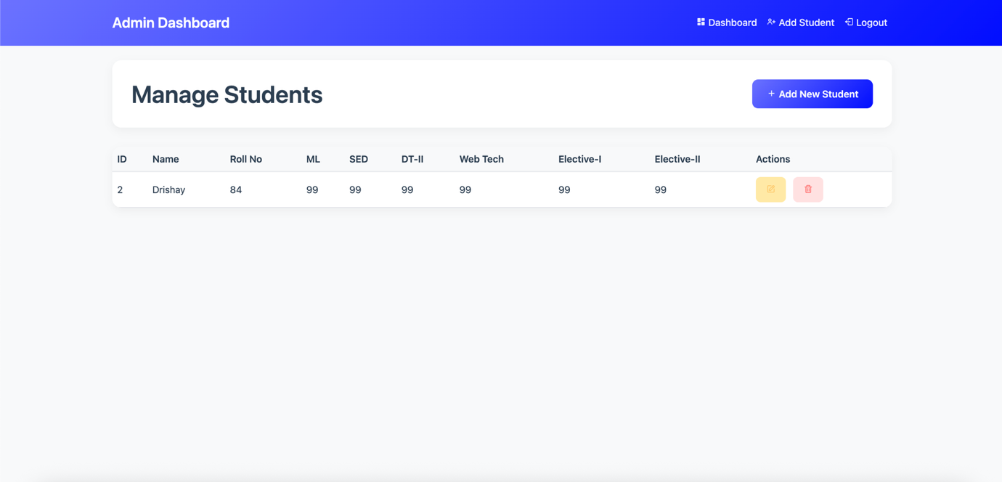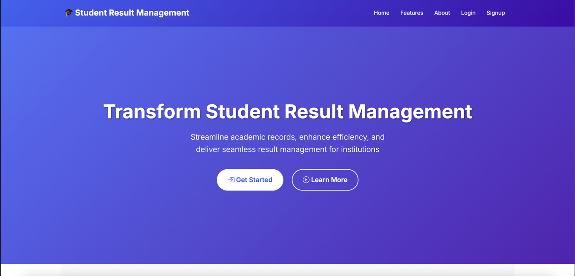

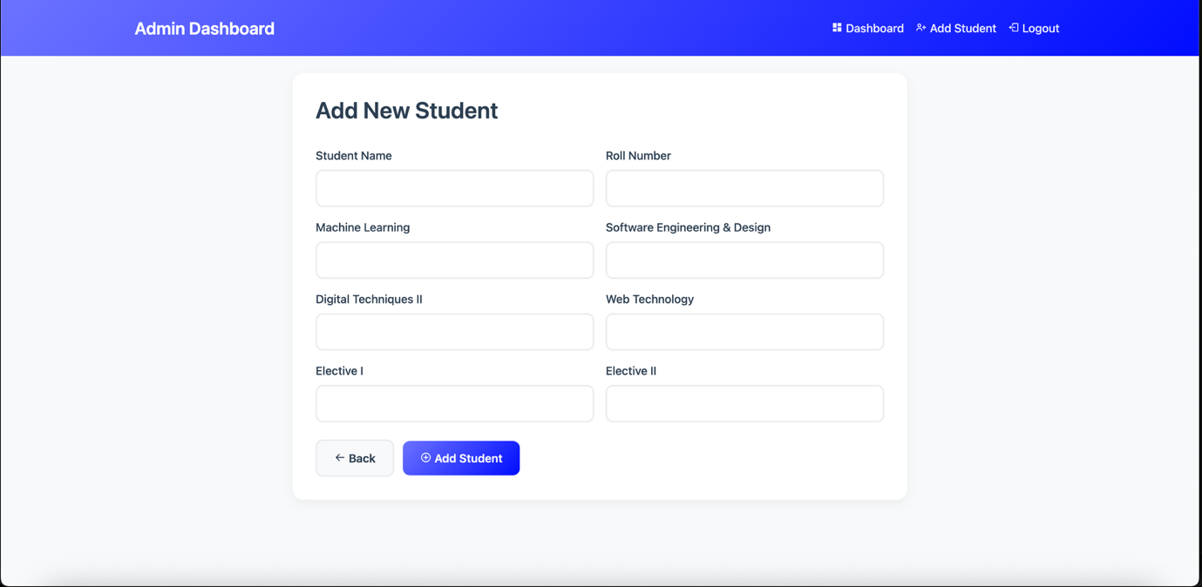

**Index.php**

<?php

session_start();

// Redirect based on logged-in role

if (isset($_SESSION['role'])) {

    if ($_SESSION['role'] === 'admin') {

        header("Location: dashboard_admin.php");

        exit;

    } elseif ($_SESSION['role'] === 'student') {

        header("Location: dashboard_student.php");

        exit;

    }

}

?>

<!DOCTYPE html>

<html lang="en">

<head>

    <meta charset="UTF-8">

    <meta name="viewport" content="width=device-width, initial-scale=1.0">

    <title>Student Result Management System</title>

    <link href="https://cdn.jsdelivr.net/npm/bootstrap@5.3.3/dist/css/bootstrap.min.css" rel="stylesheet">

    <link href="https://cdn.jsdelivr.net/npm/bootstrap-icons@1.10.5/font/bootstrap-icons.css" rel="stylesheet">

    <link href="https://fonts.googleapis.com/css2?family=Inter:wght@300;400;500;600;700&display=swap" rel="stylesheet">

    <style>

        :root {

            --primary: #4361ee;

            --secondary: #3a0ca3;

            --accent: #7209b7;

            --light: #f8f9fa;

            --dark: #212529;

            --gradient-start: #4361ee;

            --gradient-end: #3a0ca3;

        }

        body {

            font-family: 'Inter', 'Segoe UI', Tahoma, Geneva, Verdana, sans-serif;

            margin: 0;

            padding: 0;

            line-height: 1.6;

            color: #333;

        }

        /* Custom Navbar */

        .navbar-custom {

            background: linear-gradient(135deg, var(--gradient-start), var(--gradient-end));

            box-shadow: 0 4px 20px rgba(0,0,0,0.1);

            padding: 1rem 0;

        }

        .navbar-brand {

            font-weight: 700;

            font-size: 1.5rem;

            color: #fff !important;

        }

        .nav-link {

            color: rgba(255,255,255,0.9) !important;

            font-weight: 500;

            transition: all 0.3s ease;

            margin: 0 0.5rem;

        }

        .nav-link:hover {

            color: #fff !important;

            transform: translateY(-2px);

        }

        /* Hero Section */

        .hero {

            height: 85vh;

            background: linear-gradient(135deg, rgba(67, 97, 238, 0.9), rgba(58, 12, 163, 0.9)),

                        url('https://images.unsplash.com/photo-1523050854058-8df90110c9f1?auto=format&fit=crop&w=1470&q=80') no-repeat center center/cover;

            display: flex;

            align-items: center;

            position: relative;

            color: #fff;

        }

        .hero-content {

            position: relative;

            z-index: 1;

            text-align: center;

            width: 100%;

            padding: 0 20px;

        }

        .hero h1 {

            font-size: 3.5rem;

            font-weight: 800;

            margin-bottom: 1.5rem;

            text-shadow: 2px 2px 4px rgba(0,0,0,0.3);

        }

        .hero p {

            font-size: 1.4rem;

            margin-bottom: 2.5rem;

            font-weight: 300;

            max-width: 600px;

            margin-left: auto;

            margin-right: auto;

        }

        .btn-hero {

            min-width: 160px;

            margin: 0 10px;

            border-radius: 50px;

            font-size: 1.2rem;

            padding: 15px 30px;

            transition: all 0.3s ease;

            font-weight: 600;

            border: 2px solid transparent;

        }

        .btn-hero-primary {

            background: #fff;

            color: var(--primary);

            border-color: #fff;

        }

        .btn-hero-primary:hover {

            background: transparent;

            color: #fff;

            border-color: #fff;

            transform: translateY(-3px) scale(1.05);

            box-shadow: 0 10px 30px rgba(255,255,255,0.3);

        }

        .btn-hero-outline {

            background: transparent;

            color: #fff;

            border-color: #fff;

        }

        .btn-hero-outline:hover {

            background: #fff;

            color: var(--primary);

            transform: translateY(-3px) scale(1.05);

            box-shadow: 0 10px 30px rgba(255,255,255,0.3);

        }

        /* Features */

        .features {

            padding: 80px 15px;

            background: var(--light);

        }

        .feature-card {

            border: none;

            border-radius: 20px;

            box-shadow: 0 15px 35px rgba(0,0,0,0.1);

            padding: 40px 30px;

            text-align: center;

            transition: all 0.3s ease;

            background: #fff;

            height: 100%;

        }

        .feature-card:hover {

            transform: translateY(-10px) scale(1.02);

            box-shadow: 0 20px 40px rgba(0,0,0,0.15);

        }

        .feature-card i {

            font-size: 3.5rem;

            background: linear-gradient(135deg, var(--gradient-start), var(--gradient-end));

            -webkit-background-clip: text;

            -webkit-text-fill-color: transparent;

            margin-bottom: 20px;

            display: inline-block;

        }

        .feature-card h4 {

            color: var(--dark);

            font-weight: 600;

            margin-bottom: 15px;

        }

        .feature-card p {

            color: #666;

            font-size: 1rem;

        }

        /* Info Section */

        .info-section {

            padding: 80px 15px;

            background: #fff;

        }

        .info-section h3 {

            color: var(--primary);

            font-weight: 700;

            margin-bottom: 30px;

        }

        .info-section ul {

            list-style: none;

            padding: 0;

        }

        .info-section ul li {

            padding: 10px 0;

            font-size: 1.1rem;

            color: #555;

        }

        .info-section ul li:before {

            content: "✓";

            color: var(--primary);

            font-weight: bold;

            margin-right: 10px;

        }

        /* Footer */

        footer {

            background: linear-gradient(135deg, var(--gradient-start), var(--gradient-end));

            color: #fff;

            padding: 40px 0 20px;

        }

        .footer-content {

            display: flex;

            justify-content: space-between;

            align-items: center;

            flex-wrap: wrap;

            gap: 20px;

        }

        .footer-links {

            display: flex;

            gap: 30px;

        }

        .footer-links a {

            color: rgba(255,255,255,0.8);

            text-decoration: none;

            transition: color 0.3s ease;

        }

        .footer-links a:hover {

            color: #fff;

        }

        .social-links {

            display: flex;

            gap: 15px;

        }

        .social-links a {

            color: #fff;

            font-size: 1.2rem;

            transition: transform 0.3s ease;

        }

        .social-links a:hover {

            transform: translateY(-3px);

        }

        .copyright {

            text-align: center;

            margin-top: 30px;

            padding-top: 20px;

            border-top: 1px solid rgba(255,255,255,0.2);

            color: rgba(255,255,255,0.7);

        }

        @media (max-width: 768px) {

            .hero h1 { font-size: 2.5rem; }

            .hero p { font-size: 1.1rem; }

            .btn-hero {

                min-width: 140px;

                margin: 10px 5px;

                font-size: 1rem;

                padding: 12px 25px;

            }

            .footer-content {

                flex-direction: column;

                text-align: center;

            }

            .footer-links {

                justify-content: center;

            }

        }

        @media (max-width: 576px) {

            .hero h1 { font-size: 2rem; }

            .hero { height: 75vh; }

        }

    </style>

</head>

<body>

<!-- Navigation -->

<nav class="navbar navbar-expand-lg navbar-custom">

    <div class="container">

        <a class="navbar-brand" href="index.php">

            🎓 Student Result Management

        </a>

        <button class="navbar-toggler" type="button" data-bs-toggle="collapse" data-bs-target="#navbarNav">

            <span class="navbar-toggler-icon"></span>

        </button>

        <div class="collapse navbar-collapse" id="navbarNav">

            <ul class="navbar-nav ms-auto">

                <?php if(isset($_SESSION['user_id'])): ?>

                    <?php if($_SESSION['role'] === 'admin'): ?>

                        <li class="nav-item"><a class="nav-link" href="dashboard_admin.php">Dashboard</a></li>

                        <li class="nav-item"><a class="nav-link" href="manage_students.php">Manage Students</a></li>

                    <?php else: ?>

                        <li class="nav-item"><a class="nav-link" href="dashboard_student.php">My Results</a></li>

                        <li class="nav-item"><a class="nav-link" href="result_lookup.php">View Results</a></li>

                    <?php endif; ?>

                    <li class="nav-item"><a class="nav-link" href="logout.php">Logout</a></li>

                <?php else: ?>

                    <li class="nav-item"><a class="nav-link" href="index.php">Home</a></li>

                    <li class="nav-item"><a class="nav-link" href="#features">Features</a></li>

                    <li class="nav-item"><a class="nav-link" href="#about">About</a></li>

                    <li class="nav-item"><a class="nav-link" href="login.php">Login</a></li>

                    <li class="nav-item"><a class="nav-link" href="signup.php">Signup</a></li>

                <?php endif; ?>

            </ul>

        </div>

    </div>

</nav>

<!-- Hero Section -->

<section class="hero d-flex justify-content-center align-items-center">

    <div class="hero-content">

        <h1>Transform Student Result Management</h1>

        <p>Streamline academic records, enhance efficiency, and deliver seamless result management for institutions</p>

        <div class="hero-buttons">

            <a href="login.php" class="btn btn-hero btn-hero-primary">

                <i class="bi bi-box-arrow-in-right"></i> Get Started

            </a>

            <a href="#features" class="btn btn-hero btn-hero-outline">

                <i class="bi bi-play-circle"></i> Learn More

            </a>

        </div>

    </div>

</section>

<!-- Features Section -->

<section id="features" class="features container text-center">

    <div class="mb-5">

        <h2 class="display-5 fw-bold mb-3" style="color: var(--primary);">Powerful Features</h2>

        <p class="lead text-muted">Everything you need to manage student results securely and efficiently</p>

    </div>

    <div class="row g-4">

        <div class="col-md-4">

            <div class="feature-card">

                <i class="bi bi-shield-lock"></i>

                <h4>Advanced Security</h4>

                <p>Role-based authentication with secure session management and encrypted data protection</p>

            </div>

        </div>

        <div class="col-md-4">

            <div class="feature-card">

                <i class="bi bi-database"></i>

                <h4>Smart Data Management</h4>

                <p>Efficient CRUD operations with XML database for seamless student record management</p>

            </div>

        </div>

        <div class="col-md-4">

            <div class="feature-card">

                <i class="bi bi-file-earmark-pdf"></i>

                <h4>PDF Generation</h4>

                <p>Automated PDF result generation with professional formatting and instant downloads</p>

            </div>

        </div>

        <div class="col-md-4">

            <div class="feature-card">

                <i class="bi bi-graph-up"></i>

                <h4>Real-time Analytics</h4>

                <p>Comprehensive dashboard with performance metrics and academic progress tracking</p>

            </div>

        </div>

        <div class="col-md-4">

            <div class="feature-card">

                <i class="bi bi-phone"></i>

                <h4>Mobile Responsive</h4>

                <p>Fully responsive design that works perfectly on all devices from desktop to mobile</p>

            </div>

        </div>

        <div class="col-md-4">

            <div class="feature-card">

                <i class="bi bi-lightning"></i>

                <h4>High Performance</h4>

                <p>Optimized for speed with fast loading times and smooth user experience</p>

            </div>

        </div>

    </div>

</section>

<!-- Info Section -->

<section id="about" class="info-section container">

    <div class="row align-items-center">

        <div class="col-lg-6 mb-5 mb-lg-0">

            <img src="https://images.unsplash.com/photo-1522202176988-66273c2fd55a?auto=format&fit=crop&w=800&q=80"

                 class="img-fluid rounded-3 shadow"

                 alt="Modern Education Technology"

                 style="transform: perspective(1000px) rotateY(-5deg); transition: transform 0.3s ease;">

        </div>

        <div class="col-lg-6">

            <h3 class="display-6 fw-bold mb-4">Why Choose Our Platform?</h3>

            <p class="lead mb-4">Designed for educational institutions seeking excellence in academic management. Our platform combines cutting-edge technology with user-friendly design.</p>

            <ul class="list-unstyled">

                <li class="mb-3">✅ <strong>Role-based Access Control</strong> - Separate dashboards for admins and students</li>

                <li class="mb-3">✅ <strong>Comprehensive Student Management</strong> - Full CRUD operations with XML database</li>

                <li class="mb-3">✅ <strong>Professional Result Reports</strong> - PDF generation with institutional branding</li>

                <li class="mb-3">✅ <strong>Modern UI/UX Design</strong> - Intuitive interface with responsive layout</li>

                <li class="mb-3">✅ <strong>Secure Authentication</strong> - Protected login system with session management</li>

                <li class="mb-3">✅ <strong>Scalable Architecture</strong> - Ready for institutional growth and expansion</li>

            </ul>

            <div class="mt-4">

                <a href="signup.php" class="btn btn-primary btn-lg px-5 py-3 rounded-pill">

                    <i class="bi bi-rocket-takeoff"></i> Start Your Journey

                </a>

            </div>

        </div>

    </div>

</section>

<!-- Stats Section -->

<section class="py-5" style="background: linear-gradient(135deg, var(--gradient-start), var(--gradient-end));">

    <div class="container">

        <div class="row text-center text-white">

            <div class="col-md-3 col-6 mb-4">

                <h2 class="display-4 fw-bold">1000+</h2>

                <p class="mb-0">Students Managed</p>

            </div>

            <div class="col-md-3 col-6 mb-4">

                <h2 class="display-4 fw-bold">99.9%</h2>

                <p class="mb-0">Uptime Reliability</p>

            </div>

            <div class="col-md-3 col-6 mb-4">

                <h2 class="display-4 fw-bold">24/7</h2>

                <p class="mb-0">Support Available</p>

            </div>

            <div class="col-md-3 col-6 mb-4">

                <h2 class="display-4 fw-bold">50+</h2>

                <p class="mb-0">Institutions Trust Us</p>

            </div>

        </div>

    </div>

</section>

<!-- Footer -->

<footer>

    <div class="container">

        <div class="footer-content">

            <div class="footer-brand">

                <h4 class="mb-3">🎓 Student Result Management</h4>

                <p class="mb-0" style="color: rgba(255,255,255,0.8);">

                    Transforming education through innovative technology solutions

                </p>

            </div>

            <div class="footer-links">

                <a href="index.php">Home</a>

                <a href="#features">Features</a>

                <a href="#about">About</a>

                <a href="login.php">Login</a>

                <a href="signup.php">Sign Up</a>

            </div>

            <div class="social-links">

                <a href="#" title="Facebook"><i class="bi bi-facebook"></i></a>

                <a href="#" title="Twitter"><i class="bi bi-twitter"></i></a>

                <a href="#" title="LinkedIn"><i class="bi bi-linkedin"></i></a>

                <a href="#" title="Instagram"><i class="bi bi-instagram"></i></a>

                <a href="#" title="GitHub"><i class="bi bi-github"></i></a>

            </div>

        </div>

        <div class="copyright">

            <p class="mb-0">&copy; <?php echo date("Y"); ?> Student Result Management System. All rights reserved.</p>

            <p class="mb-0">Built with ❤️ for educational institutions worldwide</p>

        </div>

    </div>

</footer>

</body>

</html>

**Auth.php**

<?php

require_once "includes/auth.php";

require_admin();

$students = $db->getAllStudents();

?>

<!DOCTYPE html>

<html lang="en">

<head>

    <meta charset="UTF-8">

    <meta name="viewport" content="width=device-width, initial-scale=1.0">

    <title>Admin Dashboard - Student Result Management</title>

    <link href="https://cdn.jsdelivr.net/npm/bootstrap@5.3.2/dist/css/bootstrap.min.css" rel="stylesheet">

    <link href="https://cdn.jsdelivr.net/npm/boxicons@2.1.4/css/boxicons.min.css" rel="stylesheet">

    <style>

        :root {

            --primary-color: #6B73FF;

            --secondary-color: #000DFF;

            --light-bg: #f8f9fa;

            --border-color: #e9ecef;

        }

        body {

            background-color: var(--light-bg);

            font-family: 'Segoe UI', system-ui, -apple-system, sans-serif;

        }

        .navbar {

            background: linear-gradient(135deg, var(--primary-color) 0%, var(--secondary-color) 100%);

            padding: 1rem 0;

        }

        .navbar-brand {

            color: white !important;

            font-weight: 600;

            font-size: 1.5rem;

        }

        .nav-link {

            color: rgba(255, 255, 255, 0.9) !important;

            font-weight: 500;

            padding: 0.5rem 1rem;

            transition: all 0.3s ease;

        }

        .nav-link:hover {

            color: white !important;

            transform: translateY(-2px);

        }

        .dashboard-header {

            background: white;

            border-radius: 15px;

            padding: 2rem;

            margin-bottom: 2rem;

            box-shadow: 0 5px 15px rgba(0, 0, 0, 0.05);

        }

        .dashboard-title {

            color: #2c3e50;

            font-weight: 600;

            margin: 0;

        }

        .btn-add-student {

            background: linear-gradient(135deg, var(--primary-color) 0%, var(--secondary-color) 100%);

            border: none;

            padding: 0.75rem 1.5rem;

            border-radius: 10px;

            font-weight: 600;

            transition: all 0.3s ease;

        }

        .btn-add-student:hover {

            transform: translateY(-2px);

            box-shadow: 0 5px 15px rgba(107, 115, 255, 0.3);

        }

        .student-table {

            background: white;

            border-radius: 15px;

            box-shadow: 0 5px 15px rgba(0, 0, 0, 0.05);

            overflow: hidden;

        }

        .table {

            margin-bottom: 0;

        }

        .table th {

            background: var(--light-bg);

            color: #2c3e50;

            font-weight: 600;

            border-bottom: 2px solid var(--border-color);

        }

        .table td {

            vertical-align: middle;

            color: #2c3e50;

        }

        .action-btn {

            padding: 0.5rem 1rem;

            border-radius: 8px;

            font-weight: 500;

            transition: all 0.3s ease;

        }

        .btn-edit {

            background-color: #ffeaa7;

            color: #fdcb6e;

        }

        .btn-delete {

            background-color: #ffe2e2;

            color: #ff7675;

        }

        .action-btn:hover {

            transform: translateY(-2px);

        }

        .empty-state {

            text-align: center;

            padding: 3rem;

            color: #7f8c8d;

        }

        .empty-state i {

            font-size: 4rem;

            margin-bottom: 1rem;

            color: var(--primary-color);

        }

    </style>

</head>

<body>

    <nav class="navbar navbar-expand-lg">

        <div class="container">

            <a class="navbar-brand" href="#">Admin Dashboard</a>

            <button class="navbar-toggler" type="button" data-bs-toggle="collapse" data-bs-target="#navbarNav">

                <span class="navbar-toggler-icon"></span>

            </button>

            <div class="collapse navbar-collapse" id="navbarNav">

                <ul class="navbar-nav ms-auto">

                    <li class="nav-item">

                        <a class="nav-link" href="dashboard_admin.php">

                            <i class="bx bxs-dashboard"></i> Dashboard

                        </a>

                    </li>

                    <li class="nav-item">

                        <a class="nav-link" href="add_student.php">

                            <i class="bx bx-user-plus"></i> Add Student

                        </a>

                    </li>

                    <li class="nav-item">

                        <a class="nav-link" href="logout.php">

                            <i class="bx bx-log-out"></i> Logout

                        </a>

                    </li>

                </ul>

            </div>

        </div>

    </nav>

    <div class="container py-4">

        <div class="dashboard-header d-flex justify-content-between align-items-center">

            <h1 class="dashboard-title">Manage Students</h1>

            <a href="add_student.php" class="btn btn-add-student text-white">

                <i class="bx bx-plus"></i> Add New Student

            </a>

        </div>

        <div class="student-table">

            <?php if (empty($students)): ?>

            <div class="empty-state">

                <i class="bx bx-user"></i>

                <h3>No Students Found</h3>

                <p>Start by adding a new student to the system.</p>

                <a href="add_student.php" class="btn btn-add-student text-white">

                    <i class="bx bx-plus"></i> Add Student

                </a>

            </div>

            <?php else: ?>

            <div class="table-responsive">

                <table class="table table-hover">

                    <thead>

                        <tr>

                            <th>ID</th>

                            <th>Name</th>

                            <th>Roll No</th>

                            <th>ML</th>

                            <th>SED</th>

                            <th>DT-II</th>

                            <th>Web Tech</th>

                            <th>Elective-I</th>

                            <th>Elective-II</th>

                            <th>Actions</th>

                        </tr>

                    </thead>

                    <tbody>

                        <?php foreach ($students as $student): ?>

                        <tr>

                            <td><?= htmlspecialchars($student['id']) ?></td>

                            <td><?= htmlspecialchars($student['name']) ?></td>

                            <td><?= htmlspecialchars($student['roll_no']) ?></td>

                            <td><?= htmlspecialchars($student['ml']) ?></td>

                            <td><?= htmlspecialchars($student['sed']) ?></td>

                            <td><?= htmlspecialchars($student['dt2']) ?></td>

                            <td><?= htmlspecialchars($student['wt']) ?></td>

                            <td><?= htmlspecialchars($student['elective1']) ?></td>

                            <td><?= htmlspecialchars($student['elective2']) ?></td>

                            <td>

                                <a href="edit_student.php?id=<?= $student['id'] ?>" class="btn action-btn btn-edit me-2">

                                    <i class="bx bx-edit"></i>

                                </a>

                                <a href="delete_student.php?id=<?= $student['id'] ?>" class="btn action-btn btn-delete"

                                   onclick="return confirm('Are you sure you want to delete this student?')">

                                    <i class="bx bx-trash"></i>

                                </a>

                            </td>

                        </tr>

                        <?php endforeach; ?>

                    </tbody>

                </table>

            </div>

            <?php endif; ?>

        </div>

    </div>

    <script src="https://cdn.jsdelivr.net/npm/bootstrap@5.3.2/dist/js/bootstrap.bundle.min.js"></script>

</body>

</html>

**Signup.php**

<?php

session_start();

if (!isset($_SESSION['user_id']) || $_SESSION['role'] !== 'admin') {

    header("Location: login.php");

    exit;

}

require_once "includes/db.php";

$students = $conn->query("SELECT * FROM students ORDER BY id DESC")->fetchAll(PDO::FETCH_ASSOC);

?>

<!DOCTYPE html>

<html lang="en">

<head>

  <meta charset="UTF-8">

  <title>Manage Students - Admin Panel</title>

  <link href="https://cdn.jsdelivr.net/npm/bootstrap@5.3.2/dist/css/bootstrap.min.css" rel="stylesheet">

  <style>

      body { background: #f4f6f9; }

      .navbar { background: linear-gradient(90deg, #007bff, #0dcaf0); }

      .navbar-brand, .nav-link { color: #fff !important; font-weight: 500; }

      .card { border-radius: 15px; box-shadow: 0 4px 12px rgba(0,0,0,0.1); }

      .btn-sm { border-radius: 8px; }

  </style>

</head>

<body>

<nav class="navbar navbar-expand-lg">

  <div class="container-fluid">

    <a class="navbar-brand" href="#">Admin Panel</a>

    <div class="collapse navbar-collapse">

      <ul class="navbar-nav ms-auto">

        <li class="nav-item"><a class="nav-link" href="dashboard_admin.php">Dashboard</a></li>

        <li class="nav-item"><a class="nav-link" href="add_student.php">Add Student</a></li>

        <li class="nav-item"><a class="nav-link active" href="manage_students.php">Manage Students</a></li>

        <li class="nav-item"><a class="nav-link" href="logout.php">Logout</a></li>

      </ul>

    </div>

  </div>

</nav>

<div class="container py-4">

  <div class="card p-4">

    <h3 class="fw-bold mb-3">Manage Students</h3>

    <table class="table table-hover table-striped align-middle">

      <thead class="table-primary">

        <tr>

          <th>ID</th>

          <th>Name</th>

          <th>Roll</th>

          <th>Machine Learning</th>

          <th>SED</th>

          <th>DT-II</th>

          <th>Web Tech</th>

          <th>Elective-I</th>

          <th>Elective-II</th>

          <th>Actions</th>

        </tr>

      </thead>

      <tbody>

        <?php foreach ($students as $s): ?>

        <tr>

          <td><?= $s['id']; ?></td>

          <td><?= htmlspecialchars($s['name']); ?></td>

          <td><?= htmlspecialchars($s['roll_number']); ?></td>

          <td><?= $s['ml']; ?></td>

          <td><?= $s['sed']; ?></td>

          <td><?= $s['dt2']; ?></td>

          <td><?= $s['wt']; ?></td>

          <td><?= $s['elective1']; ?></td>

          <td><?= $s['elective2']; ?></td>

          <td>

            <a href="edit_student.php?id=<?= $s['id']; ?>" class="btn btn-warning btn-sm">Edit</a>

            <a href="delete_student.php?id=<?= $s['id']; ?>" class="btn btn-danger btn-sm" onclick="return confirm('Delete this student?')">Delete</a>

            <a href="view_result.php?id=<?= $s['id']; ?>" class="btn btn-info btn-sm">View</a>

          </td>

        </tr>

        <?php endforeach; ?>

      </tbody>

    </table>

  </div>

</div>

</body>

</html>